OV Theatre Makers
Application: video or audio submission
To help us get to know you a little better and find out why you want to be part of the programme we ask all applicants to submit a short video or audio file alongside the application form. This is an opportunity for you to showcase your creativity and ideas in a non-written format.
Your video or audio file should tell us:
- Why would you like to take part in the programme?
- What theatre do you make or would you like to make and why?
- What theatre inspires you?
Your video or audio file should be:
- Maximum two minutes long
- As creative as possible. Think about how you can show or tell us things in a creative way
- You do not need to use any specialist equipment. In the past, applicants have used their phone to record a video or voice note. You could also use a computer or laptop at a local library
- Your face and/or voice doesn’t need to appear in your video if you would rather not appear.
When the selection panel view or listen to your submission, they will be assessing you on the following things:
- Clarity: how clearly you articulate why you want to take part and what you want to make
- Creativity: the way that you tell us why you want to take part and what you want to make
- Your interest in theatre
- Your understanding of the OV Theatre Makers programme
- Your interest in developing your own theatre making skills.
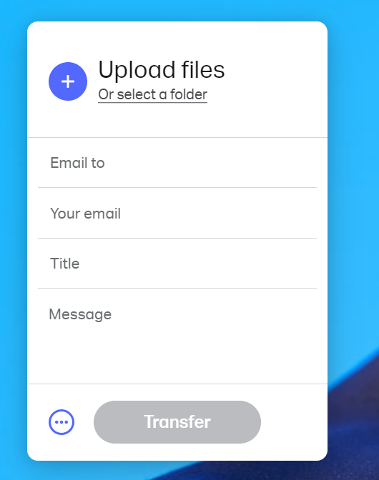
How to submit your video or audio
You should create and submit your video or audio file before you complete the application form. We will only consider candidates who have done both parts of the application.
- Please email your video or audio file to ovtheatremakers@oldvictheatre.com, including your full name in the email
- You can send your file for free using WeTransfer if it is too big to send as an attachment
- On the WeTransfer webpage you will find a box (pictured right) where you can upload your file using the blue plus button
- Make sure to include our email address in the ‘Email to’ field and please include your full name and the project ‘OV Theatre Makers’ in the ‘Message’ field so we can easily match up your video or audio file with your application form
- We will send you a confirmation email to let you know that we have received your application within 3–4 days of receipt.
If any part of the application process is not accessible for you, please get in touch and we can discuss alternative ways to apply. You can email ovtheatremakers@oldvictheatre.com or call us on 0203 954 3155.
If you have any questions or run into any issues submitting your video, please do not hesitate to contact us. We cannot wait to see and hear your ideas!

